1. Solve Josephus's Problem for 7 soldiers using JavaScript. (You can try to solve it with classes)

Display in the console

* 1. *1 Kills 2*
  2. *3 Kills 4*
  3. *5 Kills 6*
  4. *7 Kills 1*
  5. *3 Kills 5*
  6. *7 Kills 3*
  7. *7 Remains alive*

2. **EXAM** Write a program that will solve simple sudoku (not only the example below!)

Start

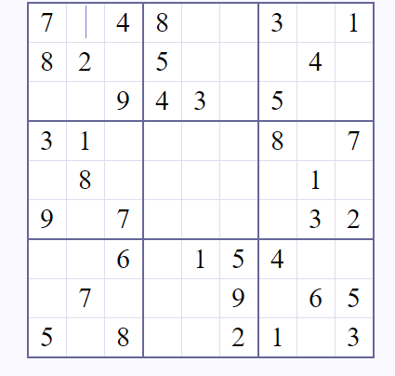

Solution

